NUC-C3 J3160
Intel® Celeron® J3160 Quad Core Processor Micro Firewall Appliance

Features：
◇ All aluminum structure，fanless design；
◇ Onboard Intel Celeron J3160 quad core processor；
◇ Max. Support DDR3L 1600 8G RAM；
◇ Support 2*MINI PCI-E Slot；
◇ Support 2*HDMI；
◇ Support 4*Intel 1000M LAN；
◇ Support OS：






Specification
Model | NUC-C3 J3160
Color | Black (Color can be customized)
Material | High-quality all aluminum，surface anodic oxidation
Processor | Intel Celeron J3160（Quad core quad threading，1.6 GHz，Max turbo 2.24GHz）
RAM | Support 1*DDR3L 1600MHz SODIMM RAM Slot，Max. Support 8GB
Display Chip | Integrated Intel HD Graphics
Display Port | 2*HDMI（Support synchronous/asynchronous dual display）
Front I/O | 1*Power Switch，1*Audio (Support Mic and Speaker at the same time)，2*USB3.0，1*RJ45 COM（Support Console Function）
Front I/O | 2*HDMI
Rear I/O | 4*RJ45 LAN，1*DC Input
Expansion Slot | Support 1*MINI PCIE Slot（Support USB Channel WIFI）
Expansion Slot | Support 1*MINI PCIE Slot（Support MSATA）
Network | 4*Intel i210-AT 1000M LAN
Storage | 1*MSATA Slot
Input Voltage | Support DC 12V Input
Other Function | Auto power on when there is electricity、 Timing boot、Wake on LAN、PXE boot、Watchdog（0～255 level）(Standard version doesn’t set these function)
Work Temp | 0℃ ～ +50℃（Commercial HDD），-20℃ ～ +50℃（Industrial SSD），Surface air flow
Work Humidity | 5% ～ 95% non-condensing
Certificates | CE、 CCC、 FCC Class A、 ROHS
Dimension | 115 * 107.5 * 39mm
Net Weight | 0.5kg
Application | Business Office，HD Video Playback，Home Learning，Router，Network Security etc.
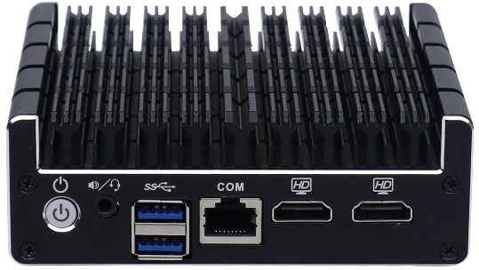
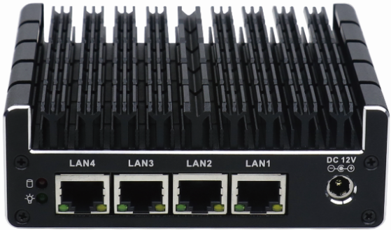
NUC-C3 J3160 Drawing
Accessories List
Name | Quantity | Specification
Power Adapter | 1 | 12V 4A
Power Cord | 1 | Any Plug Optional  (China, US, EU, UK etc.)
VESA Bracket | 1 | Standard

Order Information
Configuration 1 | NUC-C3 J3160 | Intel Celeron J3160 | Standard Port，4*LAN，2*USB

